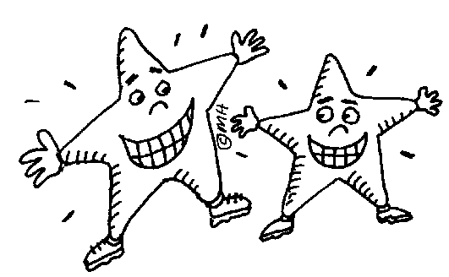
My Reading Record
Date:
Class: Number: Name:
I. Book Title:
II. Author:
III. After reading the book, I think the story is
□ interesting □ funny □ boring □ exciting □ so so □
IV. Here are some questions about the book, please write down the correct answers.
1. Who gave the pot to the little girl?
2. When the girls wants to eat, just say , and the pot will began to fill with porridge.
3. If you want the pot to stop making porridge, what should you say?

V. According to the story, please number the sentences with 1- 6.
<請按照故事內容，把發生的事件依序填上1-6 >
□ The girl gave her cracker to the old man.

□ The girl shouted ,"Little pot , stop!"
□ The girl and her mom ate the porridge.
□ The porridge poured out of the pot.
□ Everyone ate porridge with spoons.
□ The old man gave the girl a magic pot.

